PHENIKAA UNIVERSITY
PHENIKAA SCHOOL OF INFORMATION TECHNOLOGY



COURSE TITLE : SOFTWARE ARCHITECTURE
PROJECT TITLE : ANALYSIS AND SYSTEM DESIGN
FOR A LIBRARY MANAGEMENT APPLICATION

Instructor : Vũ Quang Dũng
Students : Trần Phương Nam (23010220)
Tiêu Hải Nam (23010214)
Cohort : K17
Class code : N02
Group: 04
Program : Information Technology

Ha Noi, February 5th, 2026
TT | Student ID | Name | Task Asignment | Evaluation
1 | 23010214 | Tiêu Hải Nam | - Propose the project idea  - Describe the problem, draw the C4 diagrams and the architectural model  - Write the system functions and actors description in the report  - Handle the back-end logic and services for the application | 100%
2 | 23010220 | Trần Phương Nam | - Design the Use Case Diagram  - Conduct user requirements analysis and gather system information  - Write the functional analysis, processing flows, and detailed use case descriptions  - Support editing the report content | 100%

Contents
1. Cover Page & Info 5
2. Executive Summary 5
3. Project Requirements & Goals 5
3.1 Core Functional Requirements 6
3.2 Key Quality Attributes (Architectural Goals – Non-functional Requirements) 7
3.2.1 Security 7
3.2.2 Performance 7
3.2.3 Data Consistency 7
3.2.4 Scalability 8
3.2.5 Usability & Learnability 8
3.2.6 Maintainability & Reliability 8
3.3 Proposed ASR Model 8
3.4 Use case Modeling 9
4. Architectural Design & Implementation 11
4.1.Architectural Pattern 11
4.1.1. C4 Model 11
4.1.2. Architectural Model 12
4.2. Technical Stack and Data Model 12
4.2.1. Technical Stack 12
4.2.2. Data Model 13
4.3. Implementation: Server Side Logic 14
4.3.1. Authentication Logic 14
4.3.2. Business Logic and Firestore 16
4.3.3 External API Intergration 19
4.4. Implementation: Client Side Logic 21
4.4.1. UI and Navigation 21
4.4.2. State Management 22
4.4.3. Role-based UI Rendering 22
4.4.4. Error Handling and UX 23
5. Testing and Verification 23
5.1 Testing Strategy 23
5.2 Test Environment 23
5.3. Fuctional Testing 24
5.4. Real-time Broadcast Testing 24
5.4.1 Concept of Real-time Broadcast Testing 24
5.4.2 Testing Scenario 24
5.4.3. Test Results 25
5.5 Verification of System Requirements 25
6. Conclusion & Reflection 25
6.1. Lessons Learned 26
6.2. Future Improvements 26

1. Cover Page & Info
• Project Title: Analysis and System Design For A Library Management Application
• Course Name: Software Architecture
• Student Info: Tiêu Hải Nam - 23010214
Trần Phương Nam - 23010220
• Date: February 5th, 2026

2. Executive Summary
The objective of this project is to design and develop a Library Management System that effectively supports book management, borrowing and returning operations, and user management in a multi-user environment. The system serves two primary actors: Users (library members) and Administrator.
The core architecture applied to the system is a layered architecture based on the Model - View - Controller (MVC) pattern, which clearly separates the user interface, business logic, and data management layers. This approach enhances maintainability, scalability, and reduces coupling between system components.
The system is designed to satisfy key quality attributes, including security, performance, data consistency, and reliability. Role-based authentication and authorization mechanisms ensure secure access control, while real-time data processing and transactional operations help maintain data integrity during concurrent borrowing and returning activities.
The final outcome is a well-structured and stable library management system that effectively fulfills the architectural requirements identified during the requirements elicitation and analysis phase.

3. Project Requirements & Goals
This section describes the core functionalities that the Library Management System must provide for each group of actors in the system. The functional requirements are categorized by the roles of User and Admin to ensure clear authorization boundaries and responsibilities.

3.1 Core Functional Requirements
ID | Description
PR-01 | The system must allow users to search for books by title, author, or category.
PR-02 | The system must allow users to view detailed information about a book, including the author, publication year, and availability status.
PR-03 | The system must allow users to submit book borrowing requests and return borrowed books.
PR-04 | The system must notify users about the status of their borrowing and returning activities, including overdue notifications.
PR-05 | The system must allow users to view their personal borrowing history.
PR-06 | The system must allow the Admin to add, update, delete, and manage the status of books in the library.
PR-07 | The system must allow the Admin to approve book borrowing requests and confirm book returns.
PR-08 | The system must allow the Admin to view statistics related to books, borrowing activities, and overall library status.

3.2 Key Quality Attributes (Architectural Goals – Non-functional Requirements)

3.2.1 Security
The system must ensure data security and access control through clear authentication and authorization mechanisms. User authentication is implemented using Firebase Authentication, while authorization is enforced based on user roles:
- Admin: authorized to add, update, delete, import books, and approve borrowing requests.
- User: authorized only to search for books, submit borrowing requests, and view personal borrowing history.
User data is isolated by unique identifiers (UIDs), and critical data such as book availability (available) and borrowing count (borrowCount) can only be updated through transactional mechanisms to prevent inconsistencies and fraudulent actions. The system must ensure that users cannot borrow books beyond the allowed quantity.

3.2.2 Performance
The system is required to provide a fast and smooth response experience for users. Firestore real-time streams are utilized to ensure that data is updated instantly without requiring interface reloads.
To optimize performance and reduce query costs:
- Only essential data is retrieved, such as the Top 3 most borrowed books or book lists filtered by category.
- Query limiting mechanisms are applied, and data sorting and filtering are performed on the client side to minimize redundant database queries.

3.2.3 Data Consistency
The system must ensure data integrity and consistency in a concurrent multi-user environment. Firestore transactions are applied to critical operations such as:
- Approving book borrowing requests
- Returning books
- Updating book availability
- Incrementing the borrowing count
The following data constraints must always be enforced:
- The available value must not be negative
- The available value must not exceed the total book quantity
- The borrowCount must only be incremented when a borrowing request is approved
This approach helps prevent race conditions when multiple users perform operations simultaneously.

3.2.4 Scalability
The system is designed using a clearly layered architecture (UI – Service – Model), enabling easy scalability and extensibility in the future. This architecture supports:
- The addition of new roles (e.g., librarian, teacher)
- The extension of statistical features (e.g., monthly statistics, category-based statistics)
- Changes to the user interface without impacting core business logic

3.2.5 Usability & Learnability
The system interface is designed clearly according to user roles (Admin / User), enabling ease of use and quick user onboarding. The user flow is simple and intuitive, covering registration, login, and book borrowing and returning operations.
Visual elements such as icons, consistent color schemes, animations, and top-book rankings are applied to enhance user experience and improve system accessibility.

3.2.6 Maintainability & Reliability
The source code is well-organized into dedicated services such as BookService, BorrowService, and AuthService, clearly separating business logic from the user interface. Data models support mapping and cloning methods, enabling easier system extension and maintenance.
The system validates data before performing updates and does not allow:
- Borrowing books when no copies are available
- Returning books in quantities exceeding those borrowed
A clear borrowing state management mechanism (Pending – Approved – Returned) is implemented to ensure reliability and transparency throughout the entire borrowing process.

3.3 Proposed ASR Model
• ASR: Security (Non-Functional Requirement)
• Statement:
The system must ensure data security and access control through clear authentication and authorization mechanisms, preventing unauthorized access and invalid user operations.
• Impact:
This requirement drives the architectural decision to adopt a centralized authentication mechanism and role-based access control (RBAC). The use of Firebase Authentication enables secure and scalable user identity management. User data is isolated by unique identifiers (UIDs), and critical data updates are executed through transactional mechanisms to ensure data integrity and reduce the risk of fraudulent operations. The clear separation between UI, Service, and Model layers supports access control at the business logic level, enhancing both system security and maintainability.

3.4 Use case Modeling
Use Case | Actor | Flow Description
Search Books | User | 1. The user opens the library application.  2. The user enters a search keyword (book title, author)  3. The system queries the database and displays a list of matching books.
View Book Details | User | 1. The user selects a book from the search results.  2. The system displays detailed information about the book, including author, publication year, and availability status.
Request Book Borrowing | User | 1. The user selects a book to borrow.  2. The user submits a borrowing request.  3. The system records the request and sets its status to Pending Approval.
Return Book | User | 1. The user selects a borrowed book.  2. The user initiates the return process.  3. The system updates the return status and waits for Admin confirmation.
Receive Notifications | User | 1. The system monitors the user’s borrowing and returning status.  2. The system sends notifications when a request is approved, a book is returned, or a book becomes overdue.
View Borrowing History | User | 1. The user accesses the borrowing history feature.  2. The system displays a list of previously borrowed and currently borrowed books along with their statuses.
Approve Borrow Request | Admin | 1. The admin accesses the list of borrowing requests.  2. The admin reviews request details.  3. The admin approves or rejects the request.  4. The system updates the request status and book availability.
Confirm Book Return | Admin | 1. The admin receives a book return notification from a user.  2. The admin confirms the return.  3. The system updates the book status and inventory quantity.
Manage Books | Admin | 1. The admin adds, updates, or deletes books in the system.  2. The system saves the changes and updates book data for users.
View Statistics and Reports | Admin | 1. The admin accesses the statistics feature.  2. The system displays reports related to book inventory, borrowing activities, and overall library status.

Use Case Diagram :
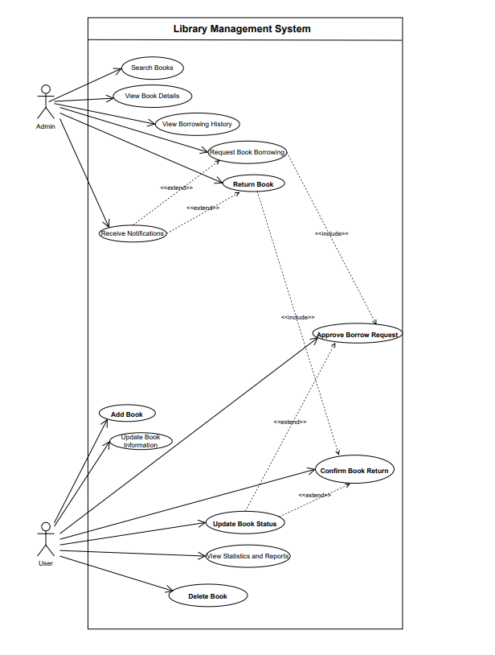

4. Architectural Design & Implementation

4.1.Architectural Pattern
The project is designed using a layered architecture combined with the MVC (Model – View – Controller) pattern, which is suitable for a Flutter application using Firebase Backend-as-a-Service.
- Applied in the project:
• Model (represents data and business structure):
Book, AppUser, Borrow
• View (Flutter user interface):
AdminHomeScreen, ImportBookScreen, ProfileScreen, AdminStatisticScreen, ManageBorrowScreen, LoginScreen, RegisterScreen, HistoryScreen, StudentHomeScreen
• Controller / Service Layer (handles business logic and communicates with Firebase):
AuthService, BookService, BookApiService, BorrowService
- Reasons for choosing this architecture:
• Clear separation between UI, logic, and data
• Easy to extend (adding roles, adding new features)
• Easy to maintain and test
• Suitable for Flutter + Firebase (client-heavy architecture)

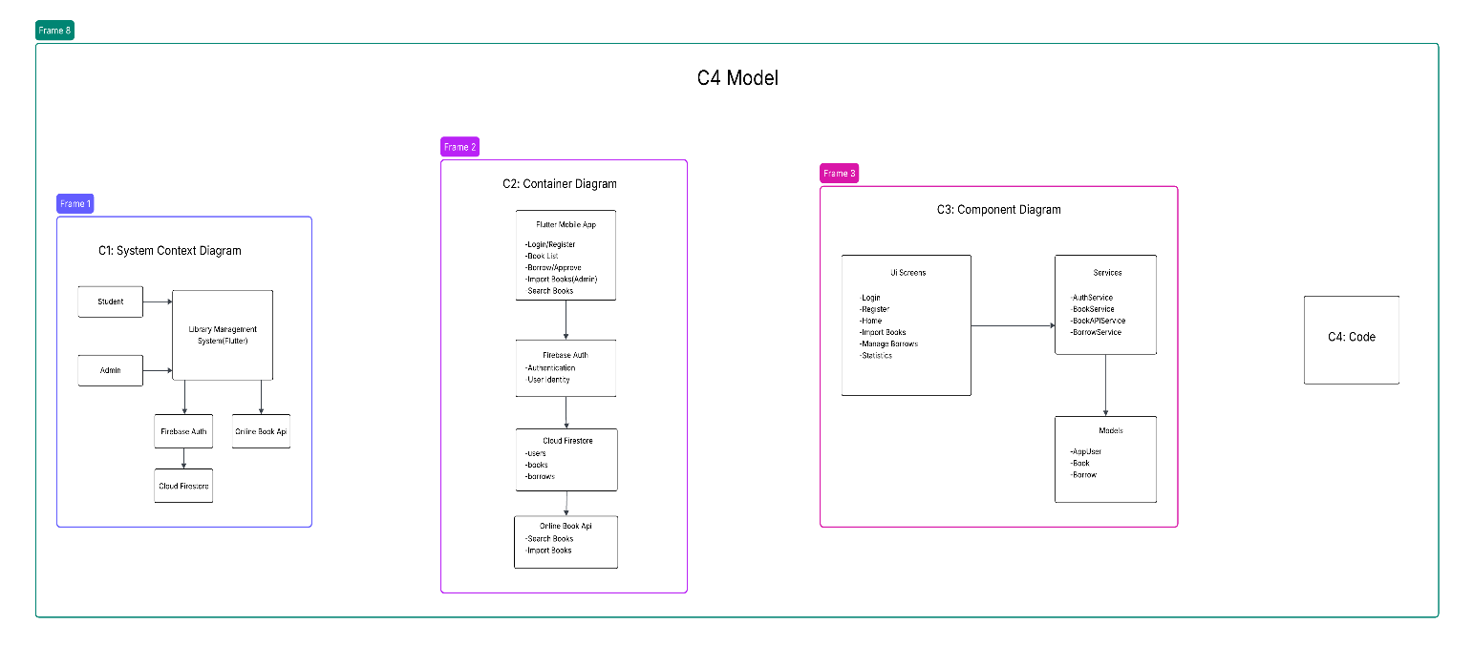

4.1.1. C4 Model

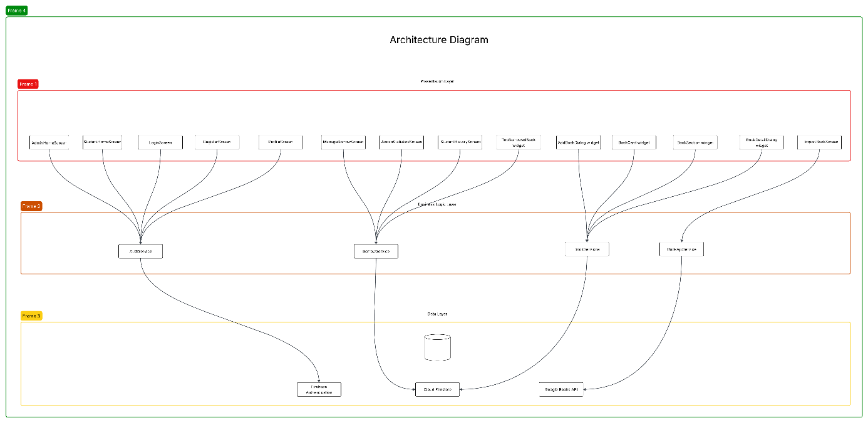

4.1.2. Architectural Model

4.2. Technical Stack and Data Model

4.2.1. Technical Stack
Components | Stack
Frontend | Flutter(Dart)
Backend | Firebase
Authentication | Firebase Authentication
Database | Cloud Firestore
External API | Google Books API
Platform | Android/IOS/Web

4.2.2. Data Model
- Collection:Users
{
“createdAt”: “Timestamp”
"uid": "string",
"email": "string",
"name": "string",
"studentId": "string",
"role": "admin | student"
}
- Collection: Borrows
{
“approved” : “bool”
“bookId”: “string”
“bookTitle”: “string”
“borrowDate”: “string”
“categoryName”: “string”
“createdAt”: “Timestamp”
“returnDate”: “Timestamp”
“returned”: “bool”
“userId”: “string”
}

- Collection: Books
{
“author” : “string”
“available”: “int”
“borrowCount”: “int”
“category”: “string”
“description”: “string”
“imageUrl”: “string”
“quantity”: “int”
“title”: “string”
}

- The data model is designed using a NoSQL approach, optimized for:
• Real-time queries
• Flexible data scalability
• Compatibility with Firestore

4.3. Implementation: Server Side Logic
- In the project, Firebase acts as the server side, handling authentication and data storage.

4.3.1. Authentication Logic
• Register / log in using Firebase Authentication
• After registration, user information is stored in Firestore
• Role-based authorization (admin, student)

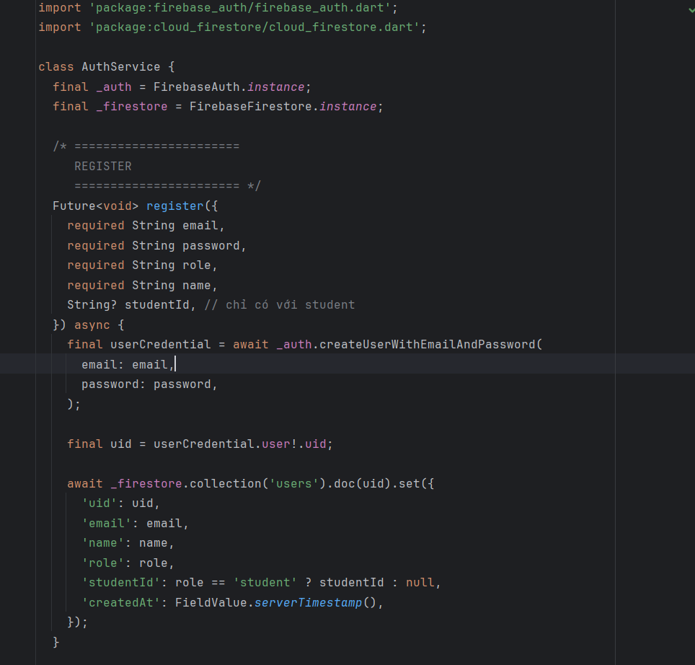

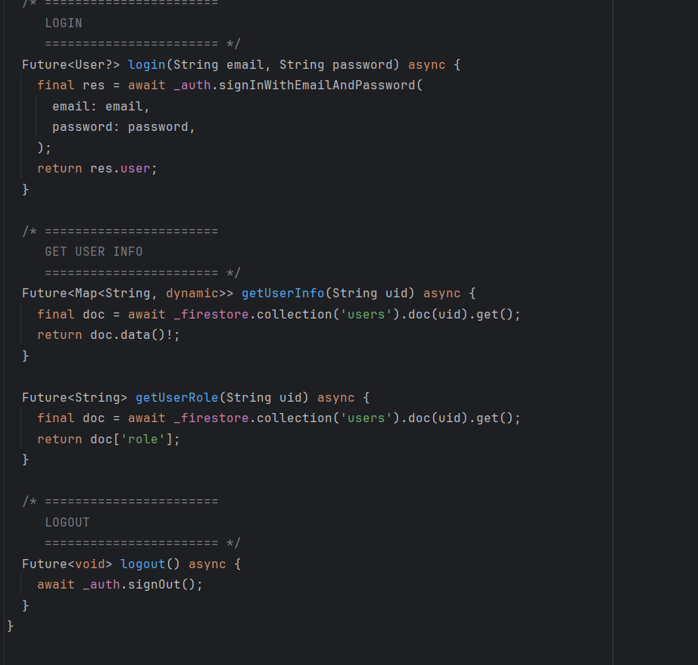

4.3.2. Business Logic and Firestore
• Add / edit / delete books (Admin)
• Borrow / return books (Student)
• Statistics for most borrowed books
• Use Firestore Transactions to ensure data integrity
Example:
• When borrowing a book:
– Decrease available
– Increase borrowCount
• When returning a book:
– Increase available (not exceeding quantity)

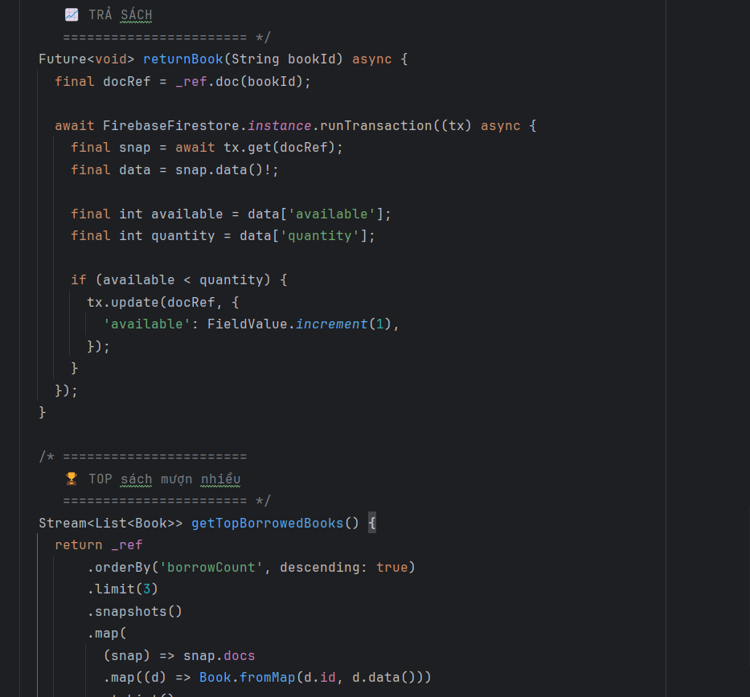

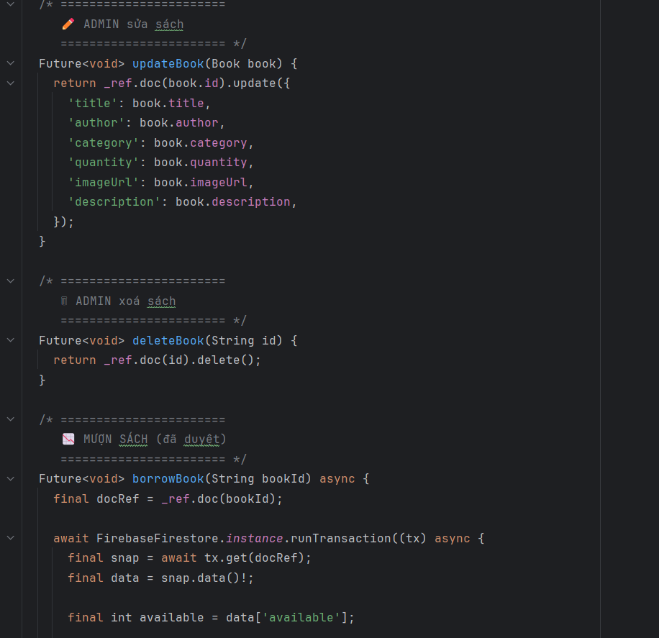

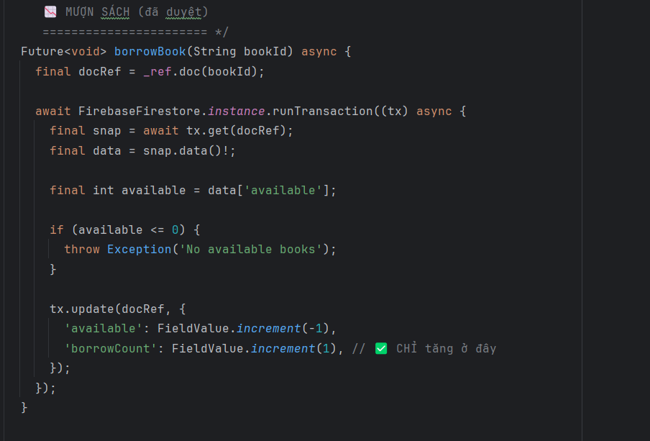

4.3.3 External API Intergration
- Integrate the Google Books API
- Search books online
- Import books directly into the system
- Error handling:
• Timeout
• Rate limit (HTTP 429)
• Empty API responses

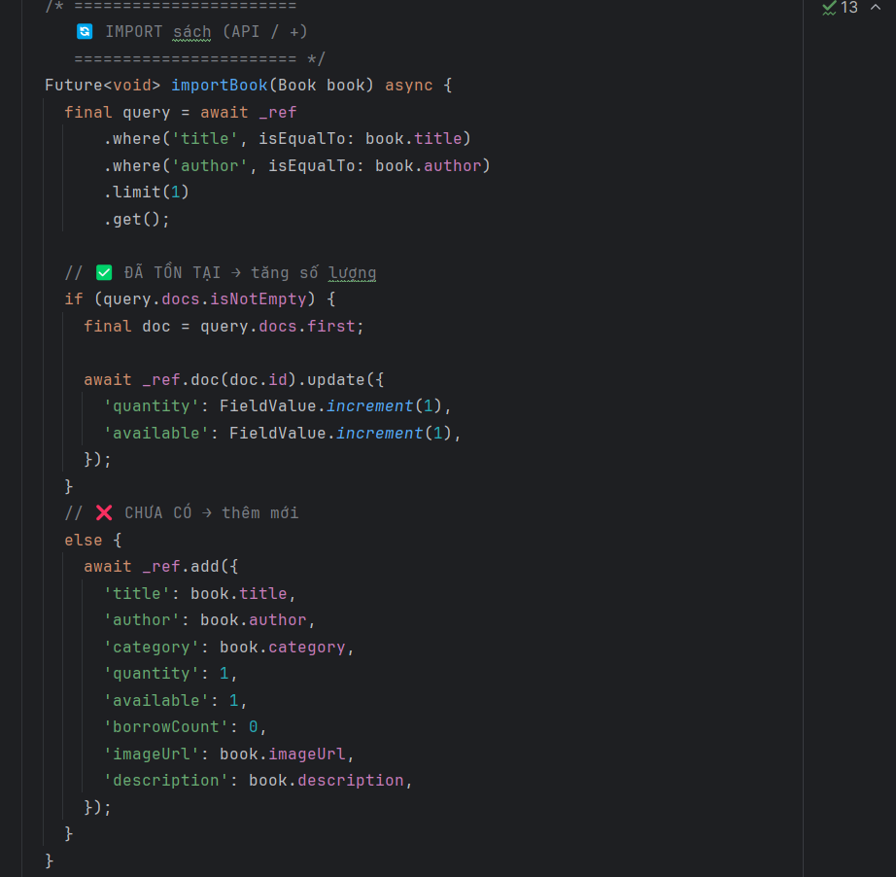

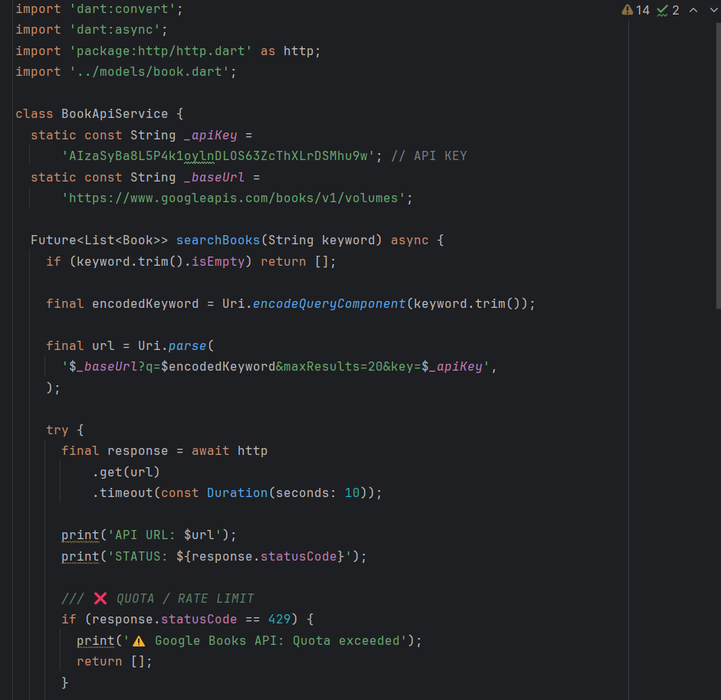

4.4. Implementation: Client Side Logic

4.4.1. UI and Navigation
- The interface is built using Flutter widgets
- Navigation is handled using Navigator
- The UI changes based on user roles:
- Admin: import, add, manage books
- Student: borrow, view books
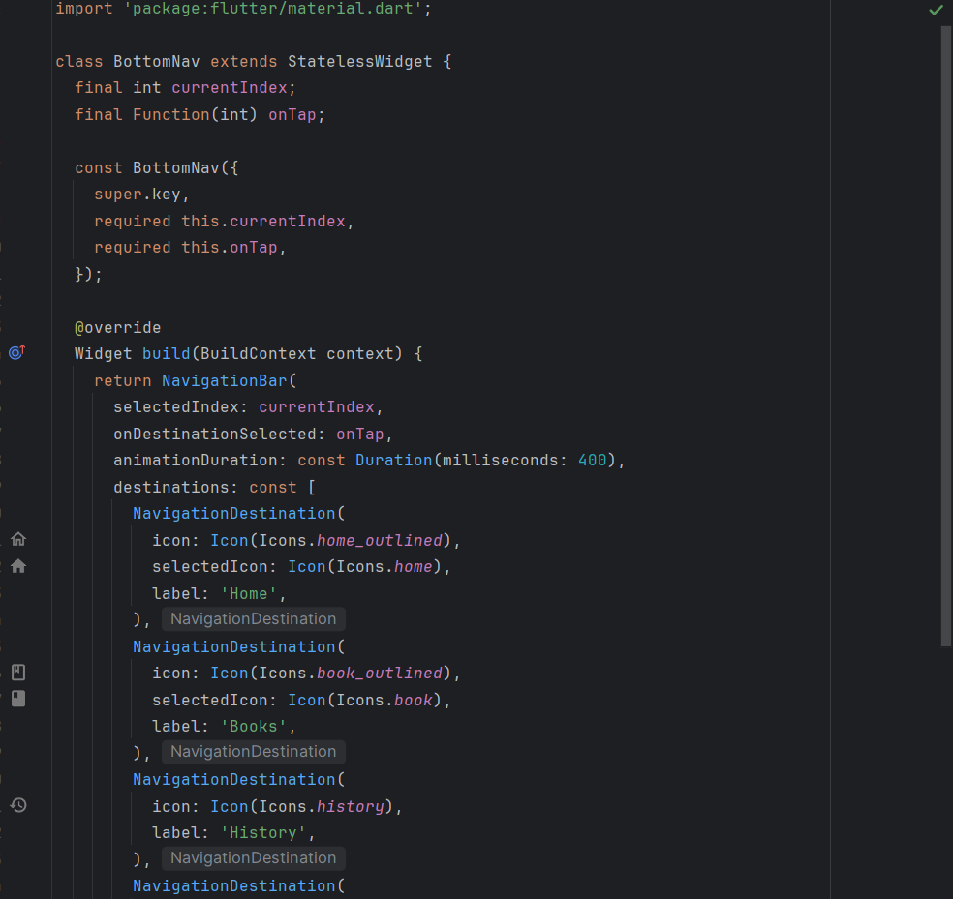

4.4.2. State Management
- Use StatefulWidget with setState
- Use StreamBuilder to:
• Display real-time data from Firestore
• Update the UI when data changes

4.4.3. Role-based UI Rendering
- After login:
• Check the user role from Firestore
• Navigate to the appropriate screen
- The profile displays:
• Email
• Name
• Student ID
• Role (Student / Admin)

4.4.4. Error Handling and UX
• Loading indicator when calling the API
• SnackBar to display status (successful import, errors)
• Prevent invalid actions (borrowing a book when unavailable)

5. Testing and Verification

5.1 Testing Strategy
The testing process was conducted to ensure that the library management application operates correctly, reliably, and consistently across different user scenarios.
Given that the application is developed using Flutter for the client side and Firebase (Firestore & Authentication) for the server side, the testing strategy focuses on both functional correctness and real-time data synchronization.
The following testing approaches were applied:
- Manual Functional Testing:
To verify that core features such as login, book search, book import, and data display work as expected.
- Multi-device Testing:
To validate system behavior when multiple users access the system simultaneously.
- Real-time Broadcast Testing:
To ensure data changes are propagated instantly across devices without requiring manual refresh.

5.2 Test Environment
The application was tested in the following environment:
- Development Tool: Android Studio
- Framework: Flutter
- Backend Services: Firebase Firestore, Firebase Authentication
- Testing Devices:
  - Android Emulator Pixel 8a (Android 16)
  - Android Emulator Pixel 9 (Android 16)
Two emulators were executed simultaneously to simulate multiple users interacting with the system in real time.

5.3. Fuctional Testing
Feature | Test Description | Expected Result | Status
User Login | Login with valid credentials | User is authenticated successfully | Pass
User Login | Login with invalid credentials | Error message displayed | Pass
Book Search | Search book by title/keyword | Correct books displayed | Pass
Book Import | Import new book data | Book stored in database | Pass
Book Display | Load book list from Firestore | Book list displayed correctly | Pass

These tests confirm that all core functionalities of the application meet the system requirements.

5.4. Real-time Broadcast Testing

5.4.1 Concept of Real-time Broadcast Testing
Real-time broadcast testing verifies whether data changes made by one user are automatically synchronized and reflected on other devices in real time without requiring manual refresh or application restart.
In this application, Firebase Firestore real-time listeners are used to broadcast data updates across all connected clients.

5.4.2 Testing Scenario
To test real-time broadcast functionality, the following scenario was executed:
- Device 1 (Pixel 8a): Logged in as an administrator
- Device 2 (Pixel 9): Logged in as a regular user
Test Steps:
- Both devices launch the application simultaneously.
- Device 2 opens the book list screen.
- Device 1 imports a new book into the system.
- Observe the book list on Device 2.
Expected Result:
- The newly added book appears instantly on Device 2 without manual refresh.

5.4.3. Test Results
Action | Device 1 | Device 2
Import new book | Book added successfully (Admin)
Data synchronization |  | Book list updated automatically(Student)
Refresh required | No | No

5.5 Verification of System Requirements
The testing results verify that the system satisfies the following requirements:
- The application supports simultaneous access by multiple users.
- Data is synchronized across devices in real time.
- The system remains stable during concurrent operations.
- No manual refresh is required to receive updated data.
These results demonstrate that the system is reliable and suitable for real-world usage in a library management context.

6. Conclusion & Reflection
This project successfully analyzed and designed a comprehensive Library Management System that supports core library operations for both users and administrators.
The primary system goals-efficient book search, borrowing/return management, request approval, and notification handling-were clearly identified and addressed through well-defined functional workflows and system components.
The system design ensures data consistency, role-based access (User/Admin), and scalability, while improving the overall user experience by digitizing manual library processes such as borrowing approval, return confirmation, and inventory tracking.

6.1. Lessons Learned
• Clear Requirement Analysis:
Conducting a detailed analysis of user and admin requirements helped define accurate system functionalities, reducing ambiguity in later design stages.
• Separation of Responsibilities:
Dividing system roles between User and Admin simplified permission management and improved system security and maintainability.
• Process-Oriented Design:
Modeling key workflows such as searching, borrowing, returning, approval, and notification highlighted dependencies between system components and ensured smooth process execution.
• Data-Centered Thinking:
Designing around core entities (Book, User, Borrow Request, Loan History) emphasized the importance of structured data management for reporting and tracking purposes.

6.2. Future Improvements
- Enhanced Security:
Implement authentication and authorization mechanisms (e.g., JWT, role-based access control) to secure user sessions and admin operations.
- Automation & Notifications:
Integrate automated reminders for due dates and overdue books via email or mobile notifications to improve user compliance.
- System Scalability:
Deploy the application using a cloud-based infrastructure and adopt a microservices architecture to support larger libraries and higher concurrent users.
- Data Analytics & Reporting:
Extend the statistics module to provide advanced analytics such as popular books, borrowing trends, and user behavior insights.
- Persistence & Backup:
Integrate a robust database with regular backup mechanisms to ensure data reliability and recovery.

